VISVESVARAYA TECHNOLOGICAL UNIVERSITY
Jnana Sangam, Belgaum -590014, Karnataka State, India


A SYNOPSIS ON

“PRIVACY PRESERVING FEDERATED INTRUSION

DETECTION SYSTEM FOR HEALTHCARE IOT”
Submitted on partial fulfilment of academic requirement of Project Phase – I
BACHELOR OF ENGINEERING IN COMPUTER SCIENCE AND ENGINEERING
(IoT, CS with BT)

SUBMITTED BY:

Asiya Rishma 4DM23IC009
Aysha Taneem 4DM23IC013
Naja Fathima 4DM23IC044
Lubna Thas 4DM23IC064

UNDER THE GUIDANCE:
Mr. Abdul Jabbar H
Assistant Professor
Department of Computer Science & Engineering (IoT, CS with BT)
YIT, Moodabidri. Mangaluru, D.K.


DEPARTMENT OF COMPUTER SCIENCE AND ENGINEERING
(IoT, CS with BT)
YENEPOYA INSTITUTE OF TECHNOLOGY
NH-13, Thodar, Moodbidri - 574 225, Mangaluru, D.K.

2025-26

ABSTRACT

The rapid growth of Healthcare Internet of Things (H-IoT) devices, including wearable monitors, smart medical sensors, and remote patient monitoring systems, has significantly enhanced the quality and accessibility of healthcare services. However, these interconnected devices continuously collect and transmit sensitive patient data, making them vulnerable to cyberattacks and privacy breaches. Traditional intrusion detection systems (IDS) rely on centralized data processing, which not only increases the risk of exposing confidential information but also creates a single point of failure if the central server is compromised. To overcome these challenges, this project proposes a Federated Learning-Based Intrusion Detection System (FL IDS) tailored for healthcare IoT environments. By enabling multiple devices to collaboratively train a global detection model without sharing raw patient data, federated learning preserves privacy while maintaining strong security performance. The integration of secure communication mechanisms further strengthens the system, allowing efficient and real-time detection of cyber threats while ensuring data confidentiality and reliability.

PROBLEM STATEMENT

Healthcare IoT devices such as wearable monitors, smart sensors, and connected medical equipment collect and share sensitive patient data continuously. While these devices improve healthcare services and patient monitoring, they also create security risks because cyber attackers may target these systems to steal or manipulate data. Traditional intrusion detection systems usually collect all data in a central server, which can threaten patient privacy and create a single point of failure if the server is attacked. Therefore, there is a need for a secure and privacy preserving intrusion detection system that can detect cyber threats in healthcare IoT networks without sharing sensitive patient data.

INTRODUCTION
Healthcare Internet of Things (H-IoT) refers to the integration of medical devices, sensors, and cloud based platforms that enable real-time monitoring, diagnosis, and treatment of patients. Devices such as ECG monitors, insulin pumps, wearable fitness trackers, and smart hospital equipment continuously collect and transmit patient health data to improve medical decision making and patient outcomes. Although this interconnected ecosystem enhances efficiency and quality of care, it also expands the attack surface, making healthcare systems more vulnerable to cyber threats.
Cyberattacks on healthcare infrastructures can lead to serious consequences, including data breaches, ransomware incidents, unauthorized device manipulation, and even life-threatening disruptions to critical medical equipment. Since healthcare data is highly sensitive and valuable, cybercriminals frequently target hospitals and medical IoT networks. Traditional centralized. intrusion detection systems (IDS)
gather network traffic data into a single server for analysis, which increases privacy risks and creates a single point of failure. If the central server is compromised, the entire system becomes vulnerable to large-scale attacks.
To address these challenges, federated learning provides a decentralized machine learning approach where devices train models locally and share only model updates instead of raw data. This ensures that sensitive patient information remains within local devices or hospital servers, significantly improving privacy protection. By integrating federated learning with intrusion detection systems, healthcare IoT networks can achieve improved security, better scalability, and stronger privacy preservation while maintaining effective real-time threat detection.

OBJECTIVES

The specific objectives are:
- To develop a Federated Learning-based Intrusion Detection System for securing Healthcare IoT networks.
- To protect patient privacy by ensuring that raw medical data is not shared between devices or central servers.
- To evaluate the system’s ability to detect cyberattacks such as ransomware, DDoS, spoofing, and data tampering effectively.qw

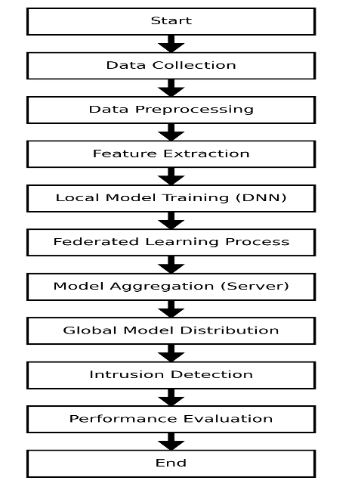
METHODOLOGY
Fig 1: Methodology of Privacy Preserving Federated Intrusion Detection System for Healthcare IoT
The proposed methodology consists of the following phases:
  - Data Collection
    - Healthcare IoT devices collect network and patient data
    - The data contains both normal activity and attack information.
  - Data Preprocessing
    - The collected data is cleaned and unnecessary values are removed.
    - The data is converted into a suitable format for model training
  - Feature Extraction
    - Important features are selected from the dataset.
    - These features help the system identify intrusion patterns.
  - Local Model Training (DNN)
    - Each device trains a Deep Neural Network using its local data
    - The model learns patterns of normal and malicious behavior
  - Federated Learning Process
    - Devices send only model parameters to the server
    - Raw data is not shared, which protects patient privacy
  - Model Aggregation
    - The server collects model updates from all devices.
    - The updates are combined to create a global model.
  - Global Model Distribution
- The updated global model is sent back to all devices.
- Devices update their models using the new information.
  - Intrusion Detection
- The trained model analyzes network activity.
- It detects whether the activity is normal or an attack
  - Performance Evaluation
- The system performance is tested using evaluation metrics
- Accuracy, Precision, Recall and F1-score are calculated.

HARDWARE / SOFTWARE USED
Hardware:
- Intel i5/i7 Processor
- 8GB/16GB RAM
- GPU (for model training)
- 256GB+ Storage Software:
- Operating System: Windows / Linux
- Programming Language: Python
- Libraries:
  - TensorFlow / PyTorch (Deep learning)
  - Scikit Learning (Machine Learning)
  - NumPy, Pandas (Data Processing)
  - Matplotlib (Visualization)
- IDE: VS Code / Jupyter Notebook

EXPECTED OUTCOME OF THE PROJECT
The expected outcomes of this project include:
- Development of a privacy-preserving intrusion detection prototype
- Detection of cyber-attacks in Healthcare IoT networks
- Improved intrusion detection accuracy using Deep Neural Networks
- Protection of sensitive patient data using Federated Learning

REFERENCES

S. S. Alsaleh, M. El Bachir Menai, and S. Al-Ahmadi,“Federated Learning-Based Model to Lightweight IDSs for Heterogeneous IoT Networks:State-of-the-Art, Challenges, and Future Directions,” IEEE Access, vol. 12, 2024. https://doi.org/10.1109/ACCESS.2024.3460468

S. Lanka and T. Moodhitaporn, “IoT Security Enhancements in Smart Healthcare Using Federated Learning,” in 2025 4th International Conference on Sentiment Analysis and Deep Learning (ICSADL), Bhimdatta, Nepal, 2025. https://doi.org/10.1109/ICSADL65848.2025.10933330

Goel S, Guleria K, Panda SN (2022) Anomaly based intrusion detection model using supervised machine learning techniques. In: 2022 10th international conference on reliability, Infocom technologies and optimization (Trends and Future Directions) (ICRITO), Noida, India, 2022, pp 1–5. https://doi.org/10.1109/ICRITO56286.2022.9965050

Vadigi S, Sethi K, Mohanty D, Das SP, Bera P (2023) Federated reinforcement learning based intrusion detection system using dynamic attention mechanism. J Inf Secur Appl 78:103608. ISSN 2214-2126. https://doi.org/10.1016/j.jisa.2023.103608

Campos EM, Saura PF, González-Vidal A, Hernández-Ramos JL, Bernabé JB, Baldini G, Skarmeta A (2022) Evaluating Federated Learning for intrusion detection in Internet of Things: review and challenges, Comput Netw 203:108661. ISSN 1389-1286. https://doi.org/10.1016/j.comnet.2021.108661

Submitted by
Asiya Rishma 4DM23IC009
Aysha Taneem 4DM23IC013
Naja Fathima 4DM23IC044
Lubna Thas 4DM23IC064

.......................... | ................................... | ….........................
Signature of the Guide | Signature of the Project Coordinator | Signature of the HOD
(Mr. Abdul Jabbar H) | (Ms. Asmitha S.E) | (Dr. Shashank M )

